ELEC 344

Lab Experiment: ___

Section: ___

Bench #: ___

Partners | Student ID #: | % participation | Signatures

Date Performed:

Date Submitted:

Task 1A, Table 1A: Armature + Brush + Wires Resistance Measurement
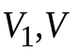 |  |  | 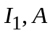 |  |  | Calculate 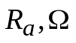
 |  |  |  |  |  | Average
Task 1B, Table 1B: No-Load Measurement
Measurement | 1 | 2 | 3 | 4 | 5 | 6
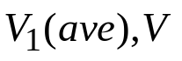
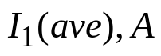
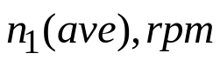
Calculation
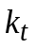, 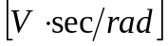
Average 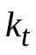
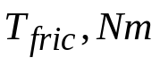
Task 2A, Table 2A: Load Test Measurement: (up to 6 measurement points)
Measurement # | 1 | 2 | 3 | 4 | 5 | 6
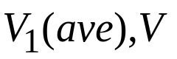
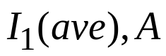
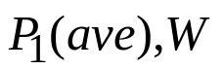
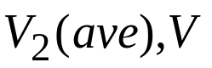
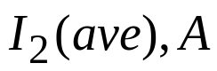
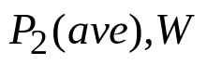
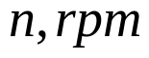
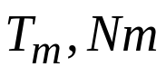
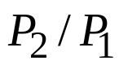

DC Machine (Generator) Voltage Constant 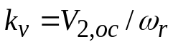
Task 2B, Table 2B: Motor Speed Control by Adjusting Voltage
Measurement # | 1 | 2 | 3 | 4 | 5 | 6
Task 3A, Table 3A: Motor Speed Control by Duty-Cycle (2.4 kHz): Vdc =
Measurement # | 1 | 2 | 3 | 4 | 5
Duty-Cycle, d
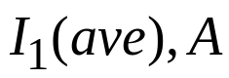
Current Ripple 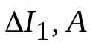
Task 3B, Table 3B: Motor Speed Control by Duty-Cycle (10 kHz): Vdc =
Measurement # | 1 | 2 | 3 | 4 | 5
Duty-Cycle, d
Current Ripple

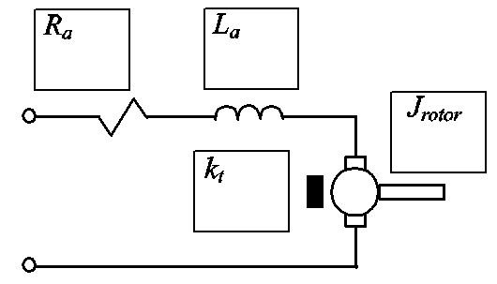
Fig. A. DC Machine Equivalent Circuit. Fill-in the corresponding boxes with machine parameters that you have identified. Make sure to include the units.
Task 4, Table 4: Motor Speed Control using Universal Inverter Box (at 5 kHz)
Measurement # |  |  |  | 1
Duty-Cycle, d
Use the set of measurements complete the following section of the Table
Input to Inverter Box |  | Input power at the DC Motor terminals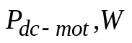 | Output mechanical power 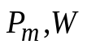 |  | Efficiency of the Inverter, % 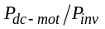 | Efficiency of the Motor, % 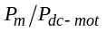 | Efficiency of Inverter-Motor combined, % 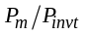
Voltage, Vdc | Current, A
Total input power to the Inverter Box 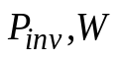
Consider the chain of the components that you had in this lab including the following:
DC Source, DC-DC Converter, DC Machine 1, DC Machine 2, and Load Resistors Box.
Using the data you recorded in Table 4, calculate and fill in the energy conversion efficiency at each energy conversion stage in the above chain. Comment on the efficiency of these stages to deliver the energy to the final resistor load.

